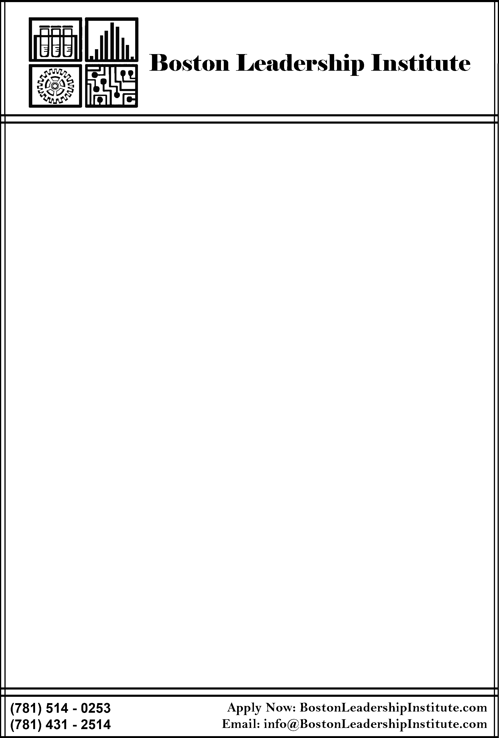

**Top Summer Science Program, 2011-2020, NY Times/thoughtco.com · Top Robotics Program, 2017, RoboLoco BioSTEM Award, 2018, J & J · Top Medicine Program, ParentMap · Top Biomedical Engineering, stocktalk.com**

**CALL FOR APPLICATIONS - SUMMER 2020**

The Boston Leadership Institute is now accepting applications for Summer 2020 STEM programs designed for high-achieving high school students. Participants engage in experimental research with faculty experts in cutting-edge areas of science. Programs are offered in fields that generate high demand STEM careers.

Programs provide:

* Hands-on, in-depth research experience that can be included in college admissions essays
* Research skills that afford students an edge in obtaining internships and research positions
* A platform to explore potential college majors and careers
* An opportunity for students to demonstrate initiative, drive, and mastery of upper level STEM subject matter

Well-equipped science labs and premier facilities provide the type of summer experience that is highly valued in college admissions. Programs take full advantage of Greater Boston locations where world-class colleges such as Harvard meet world-class biotech and medical centers to provide field trips and guest lectures. Last summer, over 500 top students were drawn to BLI competitive admissions research programs from across the country and 32 nations. Alumni now attend top-ranked universities such as MIT, Harvard, Penn, and Yale. Day or overnight options are available. Programs include:

|  |  |  |  |  |  |  |  |  |  |  |  |  |  |  |  |  |  |  |  |  |  |  |  |  |  |  |  |  |  |  |  |  |  |  |  |  |  |  |  |  |
| --- | --- | --- | --- | --- | --- | --- | --- | --- | --- | --- | --- | --- | --- | --- | --- | --- | --- | --- | --- | --- | --- | --- | --- | --- | --- | --- | --- | --- | --- | --- | --- | --- | --- | --- | --- | --- | --- | --- | --- | --- |
|  | |  |  |  | | --- | --- | --- | | **Science** | **Medicine** | **Engineering/Tech** | | Biological Research | Neuroscience & Neurosurgery | Biomedical Engineering | | Chemistry Research | Biomedical & Surgical Research | Electronics & Robotics | | Mars Mission | Oncology Research | Applied Physics & Engineering | | Biotech & Pharma Research | Emergency Medicine | Engineering Research | | Human Genetics | Epidemics & Contagion | **Business** | | Forensic Science | Veterinary Medicine | STEM Entrepreneurship | | Marine Biology | Genetics & Clinical Trials | Finance | | Astrophysics |  | Social Entrepreneurship | |  |  |  | |  |  |  | |  |  |  | | |  |  |
|  | |
|  | |
|  |  | |  |  |
|  |  | |  |  |

Visit our website and apply online at <http://bostonleadershipinstitute.com>